# CS 255 System Design Document Template

## UML Diagrams

### UML Use Case Diagram

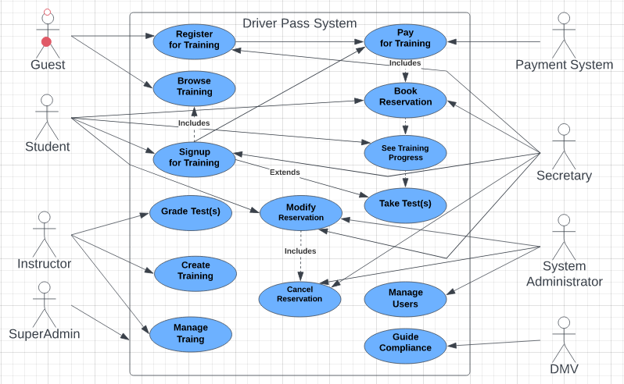

### UML Activity Diagrams

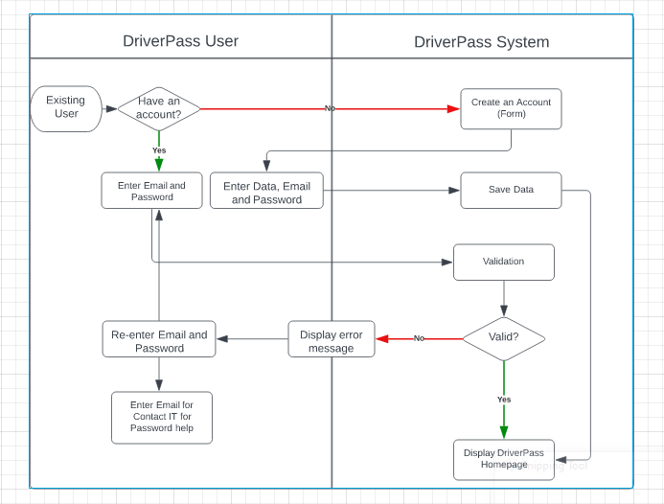

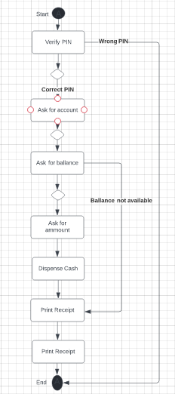

### UML Sequence Diagram

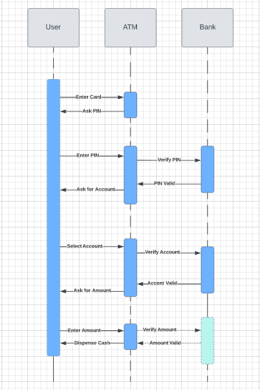

### UML Class Diagram

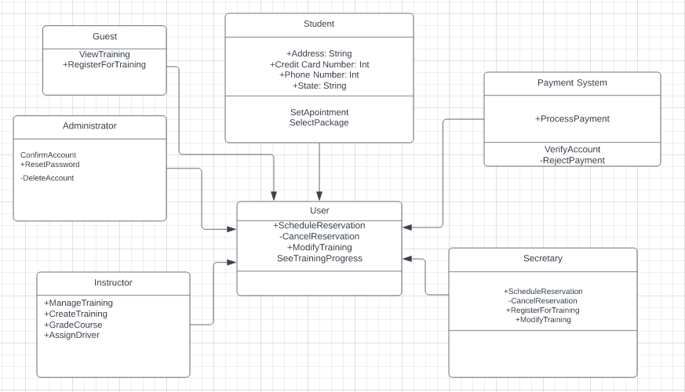

## Technical Requirements

The system itself must be capable I think the most important aspect of the system as illustrated in the diagrams is availability. The system must at the very least be able to maintain a high level (99.99%) of availability. Reliability also is important. The system should be able to maintain a time frame between failures that is reasonable enough to keep the system from creating catastrophic losses. Maintainability should also be key in ensuring that high severity system problems are repaired as quickly as possible.

**Hardware:** The system should allow users to use listening devices such as speakers/headphones/earbuds for listening to audio or videos presented in courses. Ability to use webcams as well.

**Software:** The system will have to be able to run on most web browsers (Google Chrome, Microsoft Edge, and Mozilla Firefox) and on any type of computer (desktops, laptops) that is less than a set number of years old, e.g. 5 years old. Internet Explorer is obsolete and no longer supported.

**Tools:** Adobe Acrobat reader for viewing files offline. Other optional software include Microsoft Office, Windows Media Player etc.

Infrastructure: The system will run on a platform that enables all functions and applications tied to the system to run properly. This includes architectural and design solutions that will support all the processes or adhere to all the requirements. E.g. Secure access configuration, Data source(s) (from customer database vs. the system, Interoperability will allow website to work on all major operating systems, desktop devices, data migration will allow historical data to be migrated to the new system, Internal Controls will limit access to decryption keys for customer data etc, to select individuals (Admin and Super Admin).